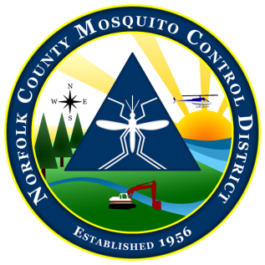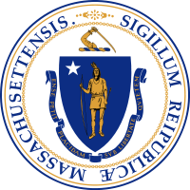

# **The Commonwealth of Massachusetts**

**The State Reclamation and Mosquito Control Board**

**Norfolk County Mosquito Control District**

144 Production Road, Suite C, Walpole, MA 02081

(781) 762-3681 fax: (781) 769-6436

www.NorfolkCountyMosquito.org

**Robin** **L. Chapell Norman P. Jacques Maureen P. MacEachern Linda R. Shea Richard J. Pollack, PhD**

Commissioners

**Caroline E. Haviland**

Field Operations Manager

**David A. Lawson**

Director

**Meeting Notice and Agenda of the Norfolk County Mosquito Control District Commission**

1:30 pm on Thursday March 25th, 2021

Join Zoom Meeting

<https://us02web.zoom.us/j/82844151327?pwd=bXJndlJTZmdub3VsUytoNGdSTlJDUT09>

Meeting ID: 828 4415 1327 Passcode: 256781

Dial by your location +1 929 205 6099 US (New York)

**MEETING PREPARATION:**

**AGENDA ITEMS THE CHAIR REASONABLY ANTICIPATES WILL BE DISCUSSED:**

1. Approval of the minutes of the February 25th, 2021 Commission Meeting
2. Budget Overview
3. Overview for FY 2021
4. Fieldwork Overview

a. Overview of 2021 year to date

1. Mosquito Control for the 21st Century Task Force update

**OTHER NOTES OR INFORMATION:**

1. New/Old Business or items to be put on next meeting’s agenda and items not anticipated.